21497 CO 119 Safety and Mobility Project (Boulder to Longmont)
Website Content

Tab 1: Home Page

Purpose
By the year 2040, the Diagonal Corridor (Colorado Highway 119 between Boulder and Longmont) is projected to see a 25% increase in vehicular traffic. This traffic increase is anticipated to result in more congestion, delay, tailpipe emissions, and potentially more crashes within the corridor. To mitigate these outcomes and expand options beyond private automobile use, multimodal improvements including Bus Rapid Transit (BRT), first and final mile connectivity, and a commuter bikeway are being planned along the corridor.

Project Overview
The CO 119 Safety and Mobility Project, a joint project between the Colorado Department of Transportation (CDOT) and the Regional Transportation District (RTD), is designing improvements to make traveling through the corridor safer for all modes and transit travel faster and more reliable. The project is being designed to integrate with other active multimodal projects on the corridor to ensure community members can safely and reliably travel throughout the corridor using their mode(s) of choice. Funding has been secured for implementation of the CO 119 Safety and Mobility Project, which is expected to go to bid for construction in fall 2023.

Project Goals
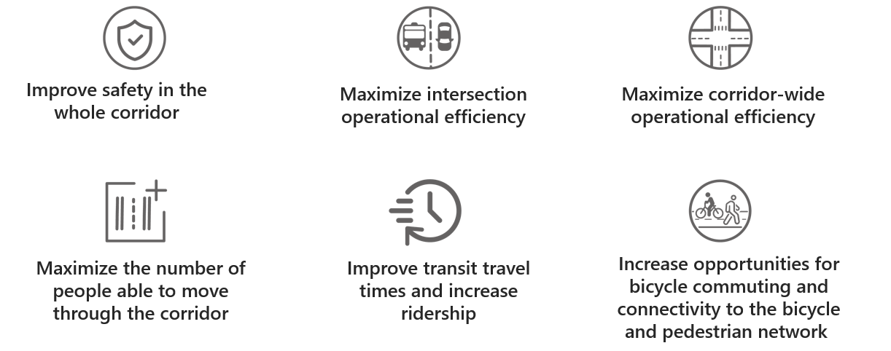

Project Area
The project extends along Colorado Highway 119 (CO 119) between Boulder and Longmont. This corridor is commonly referred to as “The Diagonal.” The southern limit of the project is Foothills Parkway in Boulder, and the northern limit is Hover Street in Longmont. Improvements are anticipated for these signalized intersections: Jay Road, 63rd Street, Colorado Highway 52 (CO 52), Niwot Road, and Airport Road. While the project’s formal limits do not extend beyond Foothills Parkway or Hover Street, the proposed Bus Rapid Transit routes extend beyond the corridor from downtown Boulder to Colorado Highway 66 north of Longmont.
Sidebar on the Homepage: Contact Us
Project Email: co119safetyandmobility@gmail.com

Project Contact:
Adnana Murtic
1050 Lee Hill Road
Boulder, Colorado 80302

Media Inquiries:
Jared Fiel
CDOT Communications Manager, Region 4
Jared.Fiel@state.co.us

Sidebar on the Home Page: Sign Up for Project Updates
Thank you for your interest in the CO 119 Safety and Mobility Project.
If you would like to receive project update emails or information about upcoming engagement opportunities, please fill out the information below and press submit.

Sidebar on the Homepage: Submit a Question or Comment
Please share your comment or question below and a member of the project team will follow up with you.
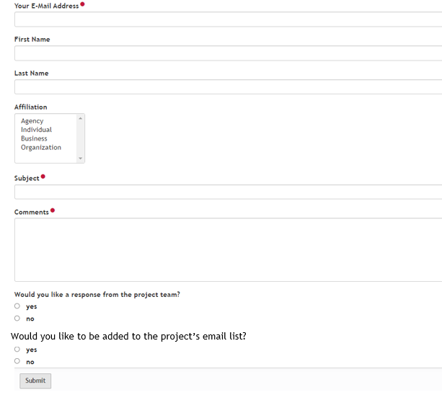

Tab 2: Project Map
The project will help to make traveling the corridor safer and more efficient for all users. New signage, striping, and improved signal timing will be implemented at all pedestrian crossings, improving pedestrian safety. Signal timing will be adjusted at key vehicular intersections (Jay Road, 63rd Street, CO 52, Niwot Road, and Airport Road). These intersections will also receive new signage, striping, and lighting. These improvements will make vehicular travel safer and more fluid. The CO 52 intersection will be physically reconfigured to improve safety and to accommodate new Bus Rapid Transit (BRT) stations and Boulder County’s Commuter Bikeway between the northbound and southbound roadways. The intersection with Hover Street will be improved through a separate project.
The project is improving the bus riding experience through implementing BRT improvements to make riding the bus faster, more reliable, and more comfortable. Park-n-Rides will be built at 63rd Street and Niwot Road. Within the project limits, new BRT stations will be constructed at 63rd Street, CO 52, and Niwot Road. The map also shows the BRT routes proposed for the corridor. The Blue Line runs every 15 minutes, and the Orange Line runs every 30 minutes. A list of all stops associated with the proposed BRT service is available here.

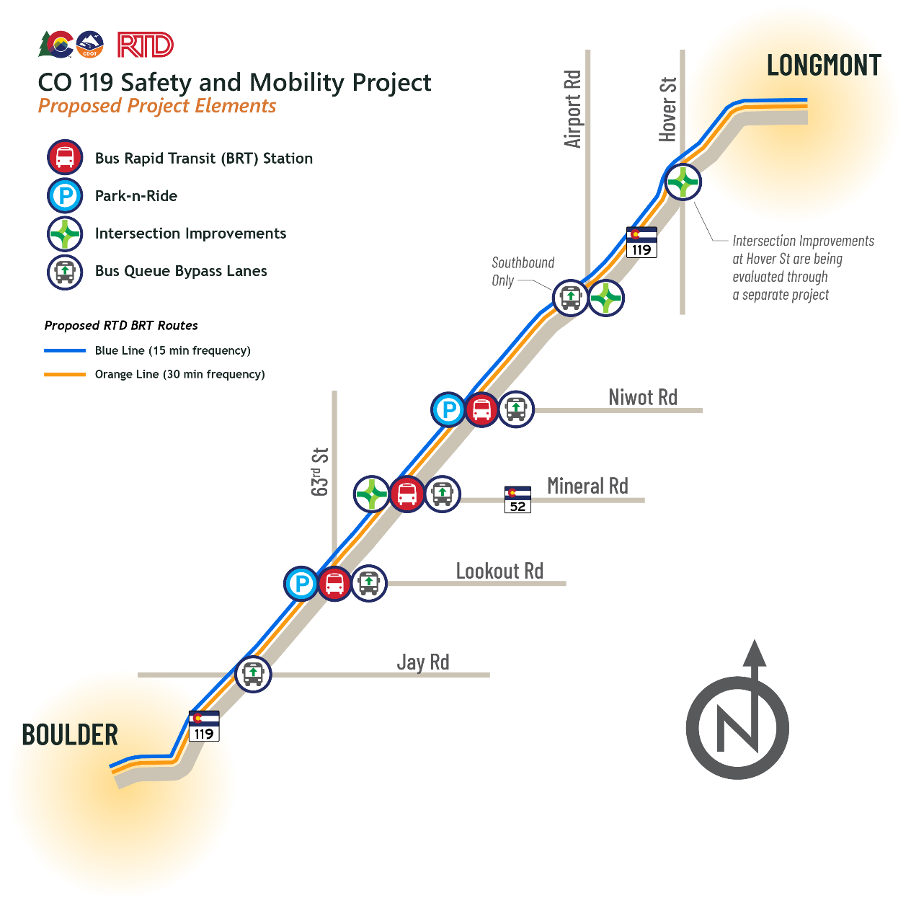

Tab 3: Benefits for Commuters
- Less fender benders and crashes
- Vehicles can move through the corridor faster, with shorter wait times at traffic lights
- Traveling the corridor by bus will take about half the time it currently does
- More frequent bus service supports greater travel flexibility
- Safer and more comfortable experience accessing the corridor on foot
- Integration between Bus Rapid Transit, Park-n-Rides, pedestrian crossings, and Boulder County’s Commuter Bikeway commuters to switch travel modes safely and reliably

Tab 4: Bus Rapid Transit
To make transit a stronger alternative to driving, the project is implementing roadway and signal improvements and introducing a new Bus Rapid Transit service on the corridor. Bus Rapid Transit, commonly referred to as BRT, is high-quality bus-based transit system designed to be more reliable, convenient, faster, and more frequent than traditional bus service. BRT achieves high quality service because it avoids the delays that can typically slow regular bus service, like making numerous stops and getting stuck in traffic at intersections. BRT systems exist all over the world, including the local Flatiron Flyer service between Boulder and Denver.

In BRT systems, buses are given a degree of “priority” over the other travel modes so that the bus can jump ahead of general traffic, providing faster and more reliable transit service. At the onset of the project, a Traffic Alternatives Study evaluated potential methods for giving buses priority on the corridor. Following the analysis, the Study recommended implementing queue bypass lanes as the bus priority tool for the corridor. Queue bypass lanes, also referred to as queue jumps, are a popular BRT tool used all over the world. The Traffic Alternatives Study determined that implementing BRT service and queue bypass lanes will shorten bus travel times in the corridor by nearly 50%!

Queue bypass lanes are short, dedicated bus only lanes that will be implemented at key signalized intersections on the corridor (Jay Road, 63rd Street, Niwot Road, and Airport Road). When a bus approaches one of these intersections, it will pull into its dedicated bus only lane. The bus will receive a special traffic signal that allows it to proceed while the general traffic is still stopped at the red light. Because buses have the special traffic signal, they can get a head start, jump ahead of the traffic, and then merge back into the general traffic lanes.

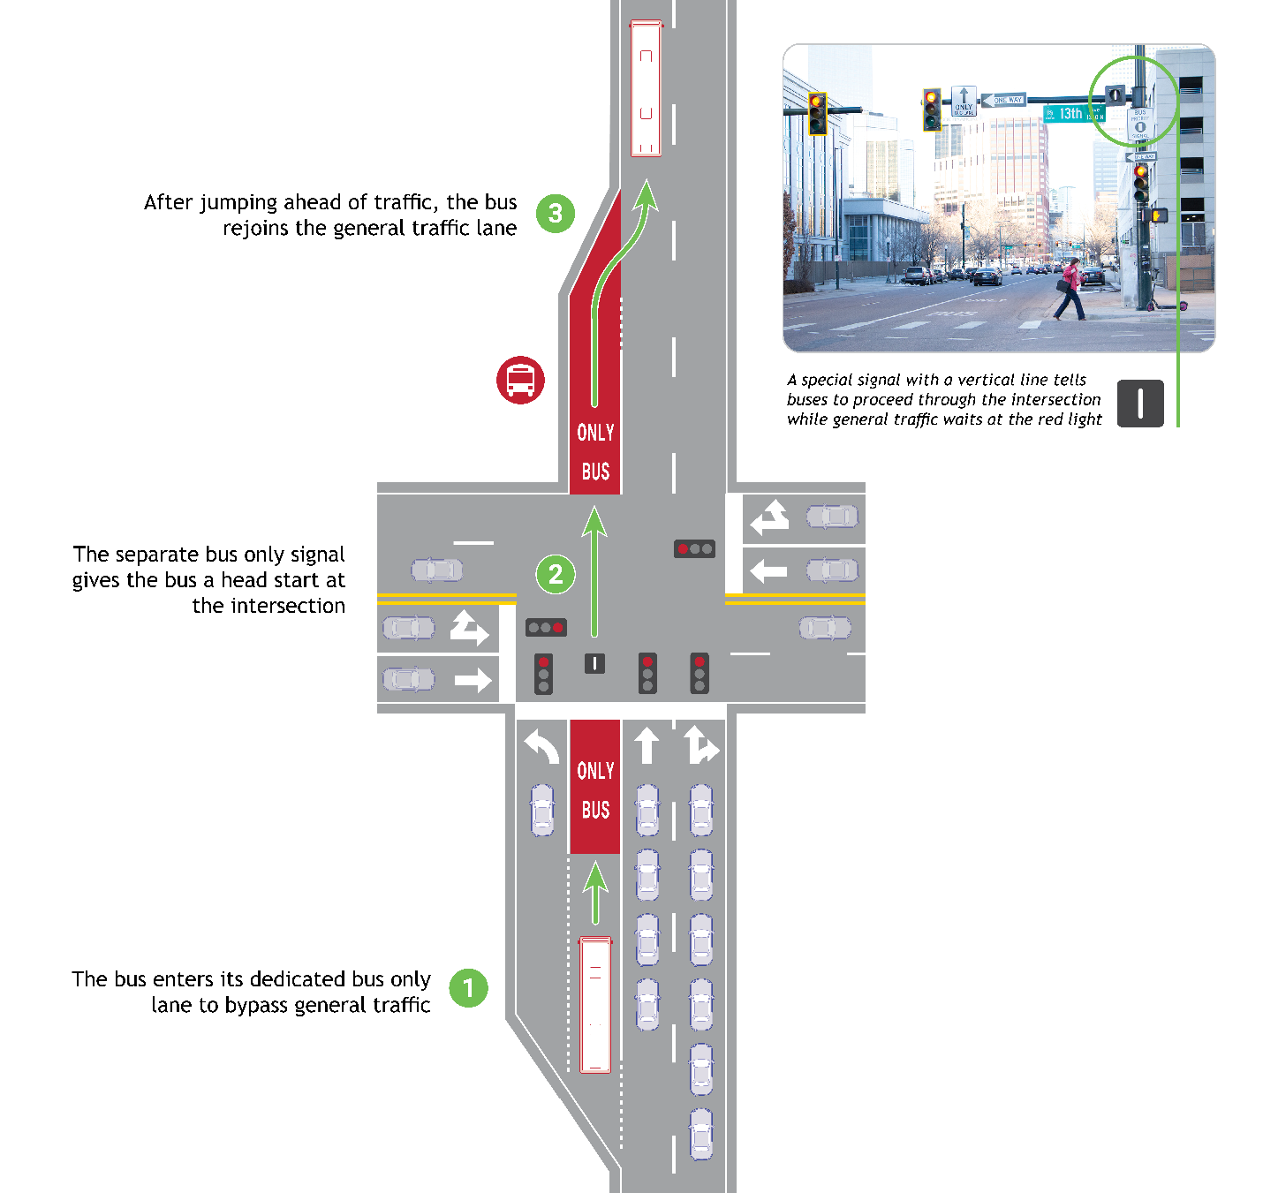

Tab 5: Mobility Throughout the Corridor
Northwest area stakeholders have established a multimodal vision for the Diagonal Corridor. In this vision, people can safely and reliably access and move throughout the corridor by walking, bicycling, riding transit, and driving. This multimodal corridor vision was established through the SH 119 Multi-Modal Planning and Environmental Linkages (PEL) Study. The PEL Study identified numerous project elements which are currently being advanced as separate projects by corridor stakeholders. To learn more these other projects, see Active CO 119 Corridor Projects.

The CO 119 Safety and Mobility Project is being designed to integrate with the other multimodal projects in the corridor to ensure community members can safely and reliably travel throughout the corridor using their mode(s) of choice. As design advances, this tab will be updated with information about how to access the Park-n-Rides, BRT stations, and Boulder County’s Commuter Bikeway by vehicle, bike, and foot.

Tab 6: Prior Planning Studies
Boulder County is one of the fastest growing areas of Colorado and area stakeholders have long advocated for improved transit to accommodate new residents and businesses. In 2014, RTD completed the Northwest Area Mobility Study (NAMS), which focused on developing consensus among RTD, CDOT, and northwest area stakeholders on cost-effective, immediate-term mobility improvements that address growing travel demand and improve mobility in the northwest region. NAMS identified the CO 119 corridor from Boulder to Longmont as a top candidate for prioritized transit service.

In 2017 RTD commissioned the SH 119 Multi-Modal Planning and Environmental Linkages (PEL) Study to implement the NAMS recommendation of optimizing regional connectivity and mobility between and within Boulder and Longmont by providing improvements that result in faster and more reliable transit travel. Whereas NAMS recommended a single Bus Rapid Transit (BRT) route for the corridor, the PEL process determined that mobility improvements should encompass a multimodal corridor vision. To implement this vision, the PEL Study identified numerous project elements, including a commuter bikeway and first and final mile connectivity, which are currently being advanced as separate projects by corridor stakeholders. To learn more these other project elements, see Active CO 119 Corridor Projects.

In reviewing the PEL Study, the Federal Highway Administration and Federal Transit Administration determined that a detailed traffic analysis is necessary before design could begin on the safety and highway capacity management improvements associated with the CO 119 Safety and Mobility Project. To meet this requirement, the Colorado High Performance Traffic Enterprise (HPTE) commissioned the Traffic Alternatives Study to identify the transit priority improvements that best advance the PEL’s and project’s goals. The Intersection Improvements and Queue Bypass Lane alternatives had the highest score in the analysis, and thus are being advanced for design through the CO 119 Safety and Mobility Project. For more information, see Traffic Alternatives Study.

Traffic Alternatives Study
The Colorado High Performance Traffic Enterprise (HPTE) commissioned the Traffic Alternatives Study, a cost benefit analysis to identify the highway capacity management and transit priority improvements that best advance the SH 119 Multi-Modal Planning and Environmental Linkages (PEL) Study goals:
- Improving safety in the whole corridor
- Maximizing intersection operational efficiency
- Maximizing corridor-wide efficiency
- Maximizing the number of people able to move through the corridor
- Improving transit travel times
- Improving connectivity to the bicycle and pedestrian network

Through the study, 7 alternatives were analyzed for year 2045 conditions:
- No Build
- Baseline (intersection improvements at CO 52, Hover, and Airport)
- Queue Bypass Lanes
- 3 General Purpose Lanes
- Tolled Express Lane (adding a new lane)
- Tolled Express Lane (converting existing lane to tolled express lane)
- Tolled Express Lane (grade-separated)

Data from the traffic analysis was scored against the goals identified in the PEL. The safety of the alternatives was assessed by reviewing crash improvements, pedestrian exposure, bike exposure, and intersection and segment conflict points. Cost was added as an additional scoring element (a Life Cycle Cost Analysis was completed), and the scores were weighted for safety, operations, and cost.

Study Findings
- Intersection Improvements and Queue Bypass Lanes tie for the highest score.
- Intersection Improvements (the Baseline) significantly improves corridor performance compared to the No-Build Alternative.
- Queue Bypass Lanes alternative is low cost and provides Bus Rapid Transit travel time savings and trip reliability.
- Tolled Express Lane Scenarios provide similar Bus Rapid Transit travel time savings and trip reliability as Queue Bypass Lanes, but at a significantly higher cost. Additionally, these scenarios increase the number of personal vehicles served in the corridor.

RECOMMENDATIONS
Intersection Improvements and Queue Bypass Lanes are recommended to be advanced for design and implementation through the CO 119 Safety and Mobility Project.

STAKEHOLDER COLLABORATION
Throughout the Traffic Alternatives Study, HPTE engaged all planning partners in the corridor including Boulder County, City of Boulder, City of Longmont, Commuting Solutions, Federal Highway Administration, RTD, and CDOT. Each of the corridor planning partners provided input and helped to guide the study process. The study’s findings were reviewed and discussed by the CO 119 leadership structure. This collaborative process led to the concurrence of the recommendations by all planning partner stakeholders. This level of collaboration provides a solid foundation for the CO 119 Safety and Mobility Project to move forward to design.

Read the Traffic Alternatives Study report here.

Tab 7: Active CO 119 Corridor Projects
The SH 119 Multi-Modal Planning and Environmental Linkages (PEL) Study identified numerous multimodal elements for the corridor. In addition to the CO 119 Safety and Mobility Project, these elements are being advanced as separate projects by corridor stakeholders, as shown below:

- Boulder County Commuter Bikeway
- City of Boulder 28th Street Improvements Project
- Commuting Solutions First & Final Mile Study
- City of Longmont Coffman Street Busway
- City of Longmont CO 119 and Hover Street

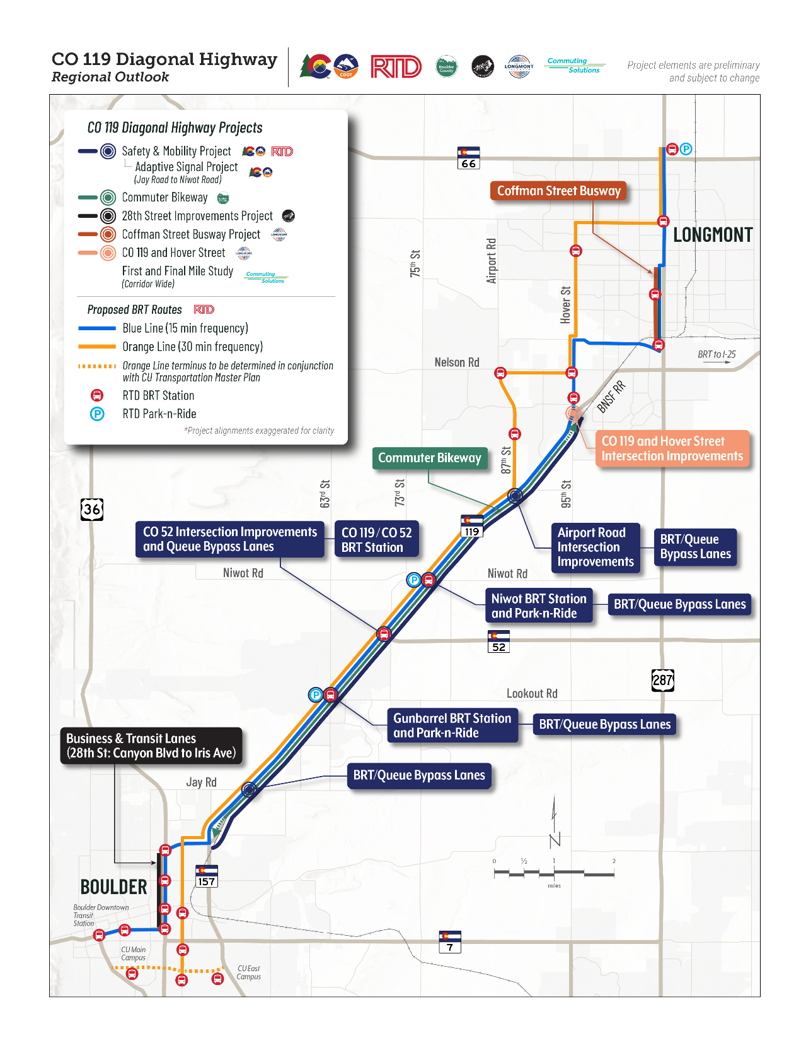

To streamline project development and to advance projects in an efficient and cost-effective manner, a formal corridor CO 119 leadership structure has been established. This structure includes representatives from all organizations with active planning projects on the corridor between 2020 and the present. The CO 119 leadership meets at minimum monthly to ensure communication and coordination across projects.

CO 119 Corridor Leadership Structure

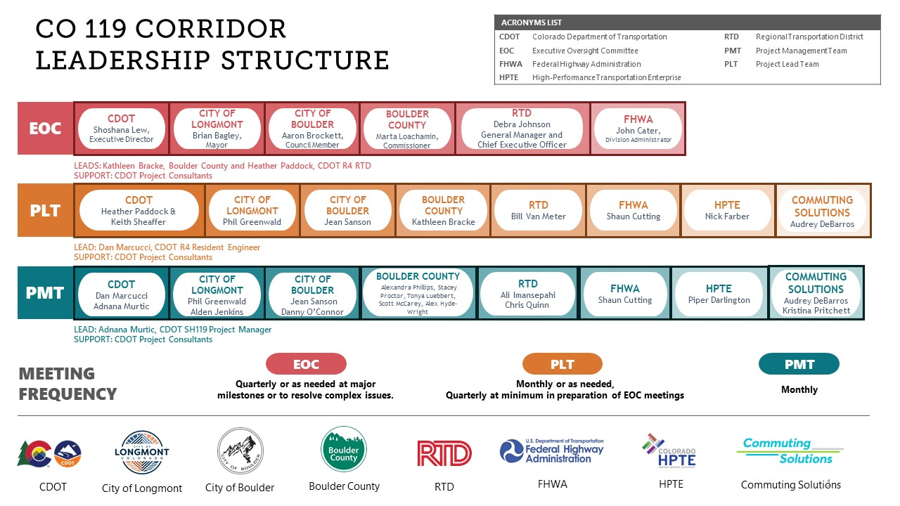

Benefits of the Coordinated Corridor Approach
- Project elements are complementary and build upon each other
- Construction activities are strategically phased and implemented as concurrently as possible (Touch Once approach)
- Across projects, public and stakeholder outreach is coordinated, preventing engagement fatigue and effectively conveying how individual projects fit into the multimodal corridor vision
- Collective resources are leveraged to secure additional corridor funding and maximize return on investment
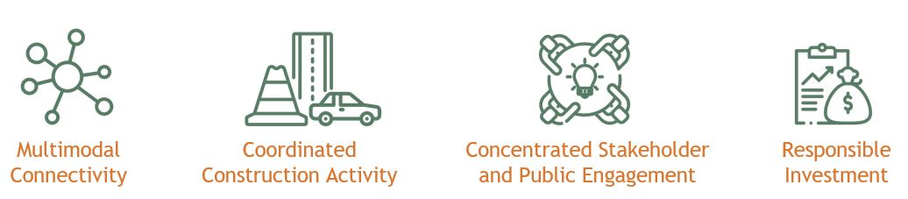

Tab 8: Provide Input!
Opportunities for public input and information about forthcoming public meetings will be posted here. Check back in spring 2021 for information on the first public meeting.

The project is being developed with guidance from area stakeholders and community members like you. Boulder County, CDOT, and RTD have established a Community Advisory Committee for the Colorado Highway 119 corridor between Boulder and Longmont. Composed of ten community members who live and/or work near the corridor, the committee serves as a focus group for the development of Boulder’s Commuter Bikeway and CDOT’s and RTD’s CO 119 Safety and Mobility Project. The committee anticipates meeting eight times between fall 2021 and spring 2023, and ensures the projects are shaped by diverse voices from a variety of community member perspectives, including people of color, people with mobility challenges, people of all ages and abilities, people who rely upon transit, the strong and confident bike commuter, and people interested in bicycling but who are uncomfortable bicycling on roads.

CDOT and RTD invite you to sign-up to receive project emails that will provide information on project developments and public engagement opportunities. You are also welcome to submit a comment or question and a member of the project team will follow up with you.

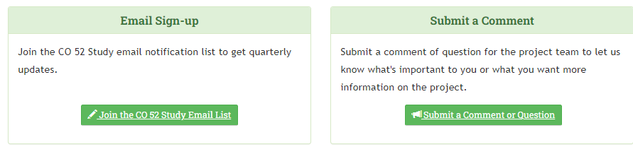
Join the Project Email List
If you would like to receive project update emails or information about upcoming engagement opportunities, please sign-up for the email list.

Tab 9: Schedule
Design of the project’s safety and mobility improvements began in winter 2021 and is anticipated to conclude in spring 2023. A public meeting is anticipated at the conclusion of Preliminary Design to share design concepts with the community. The project will have a second meeting at the end of Final Design to share the final design plans and what to expect during construction. Construction is anticipated to go to bid in fall 2023 and begin in 2024.

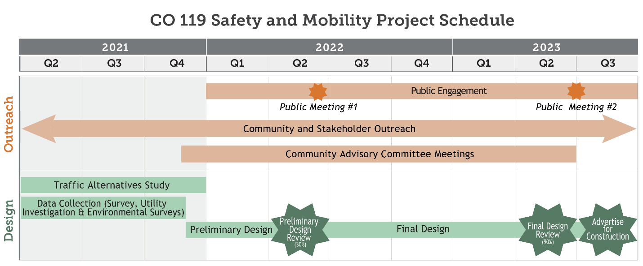

Tab 10: Jargon
Coming soon!

Tab 11: Frequently Asked Questions
Coming soon!

Tab 12: Document Library
- Northwest Area Mobility Study (NAMS)
- SH 119 Multi-Modal Planning and Environmental Linkages Study (PEL)
- Traffic Alternatives Study Report
- CO 119 Safety and Mobility Project Map
- CO 119 Corridor Projects Map
- Proposed Bus Rapid Transit (BRT) Stops

